Lab 17: Race conditions vulnerabilities
Objective:
- This lab is designed to explore Race Conditions vulnerabilities in web applications and systems. Participants will interact with a simulated environment where specific processes or actions are prone to race conditions. The objective is to understand how race conditions occur, identify their impact on application security and data integrity, exploit these vulnerabilities, and learn effective strategies to prevent them.
In this lab, students need to:
- Answer the following questions:
  - What are Race Conditions vulnerabilities, and how do they differ from other types of vulnerabilities in web applications? Explain the concept of a race condition, including how concurrent processes or threads can lead to unexpected or insecure states.
  - Describe the process of exploiting a Race Conditions vulnerability in a web application or system. What techniques can an attacker use to induce a race condition, and how can such vulnerabilities lead to security breaches or data corruption?
- Perform challenge:
  - Limit overrun race conditions
- Explain and capture all steps (full windows screen capture).
Group Members:
- Phạm Hoàng Hải Nguyên (SE180511)
- Nguyễn Trúc Quỳnh (SE180280)
- Giã Thị Nhã Trân (SE180405)

Submit a report addressing all the questions mentioned above in either PDF or Markdown format. Additionally, include a video demonstrating the detailed process of your work to ensure the authenticity of your lab exercise.
The report file name must be Class_YourStudentID _YourName_Lab17

Limit overrun race conditions
Opens the "Limit overrun race conditions" lab from PortSwigger Web Security Academy in Firefox running inside a Kali Linux VM. The lab description explains that the shop applies a discount coupon but fails to properly handle concurrent requests, making it possible to apply the same coupon multiple times. Burp Suite Professional is running in the background ready to intercept traffic. The lab status shows "Not solved".
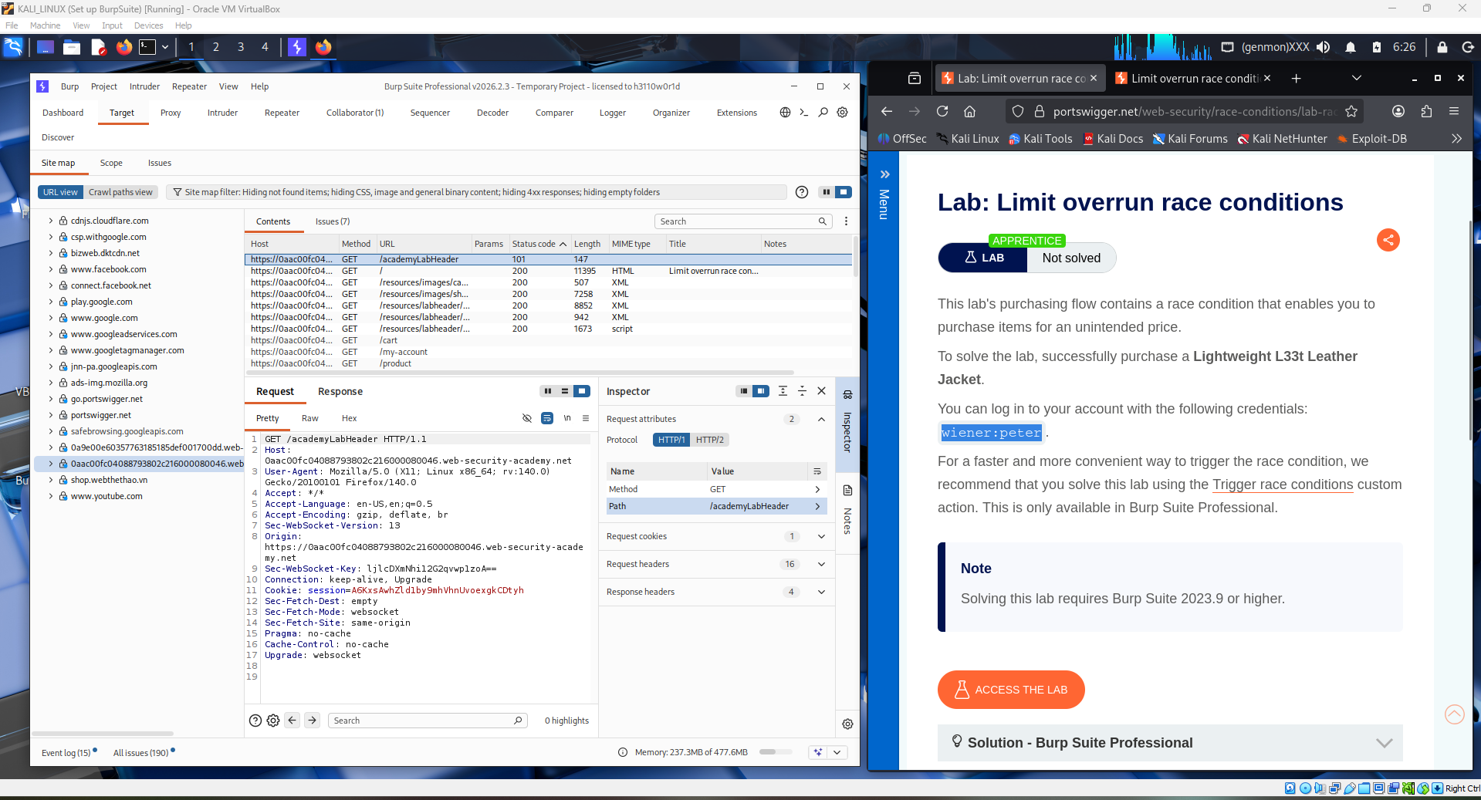

Logs into the lab application using the provided credentials. The browser navigates to the login page of the target shopping website, and the student submits the username and password. Burp Suite captures this authentication request in the background, and the session cookie is established for subsequent requests.
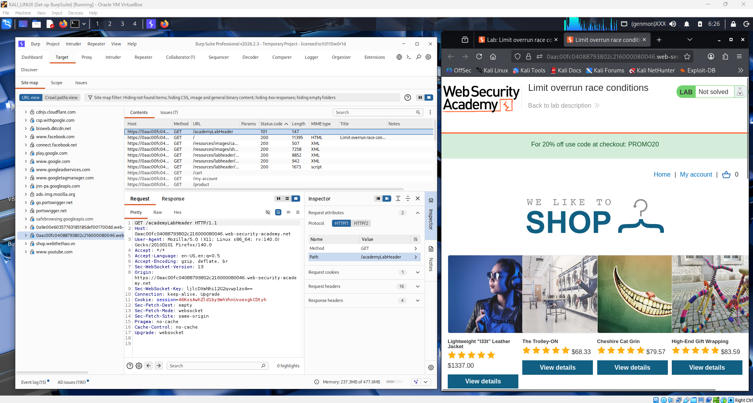
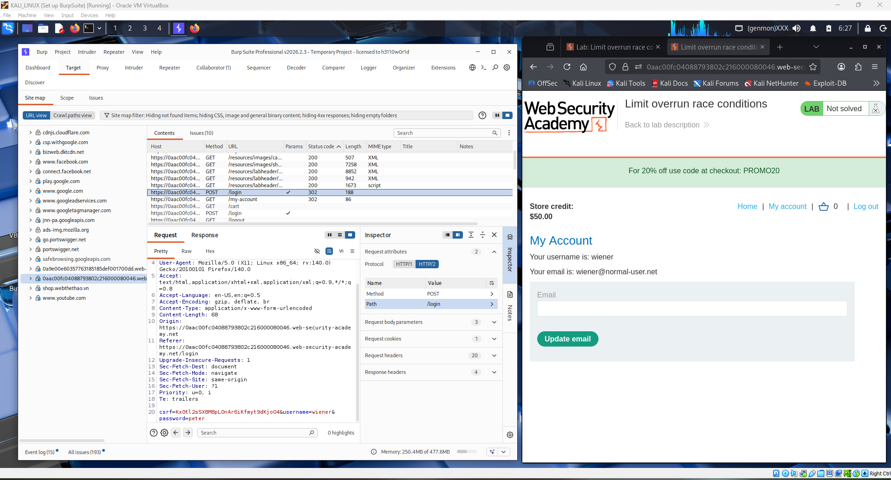

After logging in, the student browses the shop and adds the target item — a leather jacket priced at $1337.00 — to the shopping cart. This is necessary because the race condition exploit targets the coupon redemption process during checkout, so an expensive item must be in the cart to make the discount meaningful.
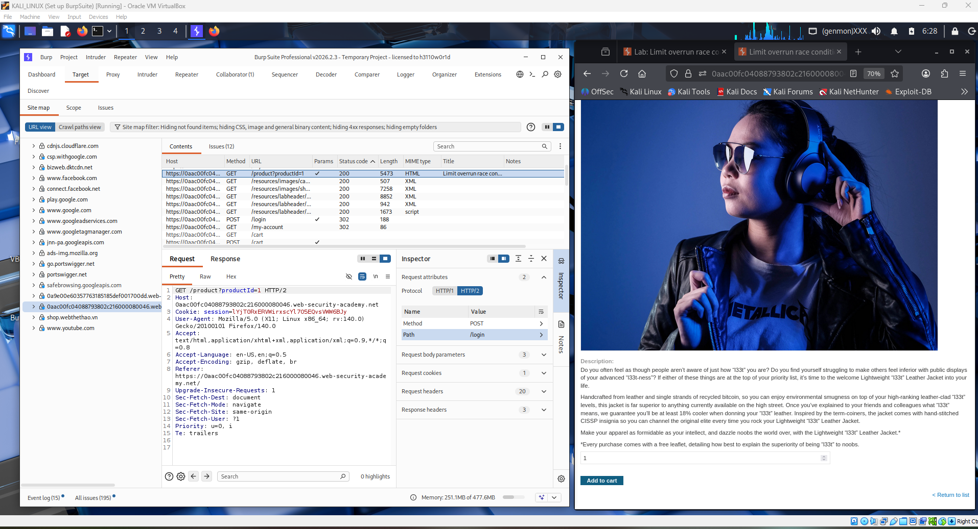
Navigates to the cart and proceeds to the checkout page. Here the coupon code field is visible. The student enters the provided promo code PROMO20 into the coupon field and submits it once normally to observe the standard behavior. The discount is applied once, reducing the total price by 20%, confirming the coupon is valid and functional.
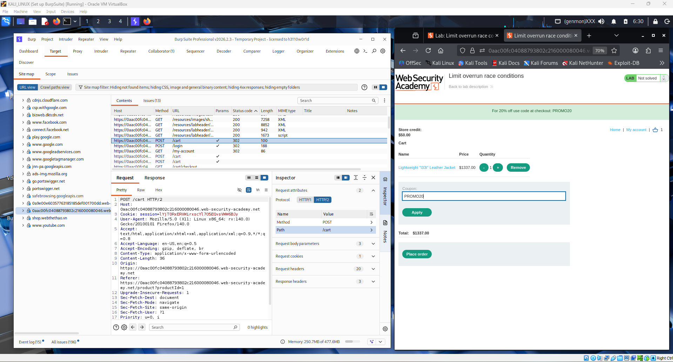
Opens Burp Suite's HTTP history and locates the POST request that was sent when the coupon was applied. This request contains the coupon code in the body and is the exact request that needs to be replicated in parallel to trigger the race condition. The student right-clicks and sends this request to the Repeater tab.
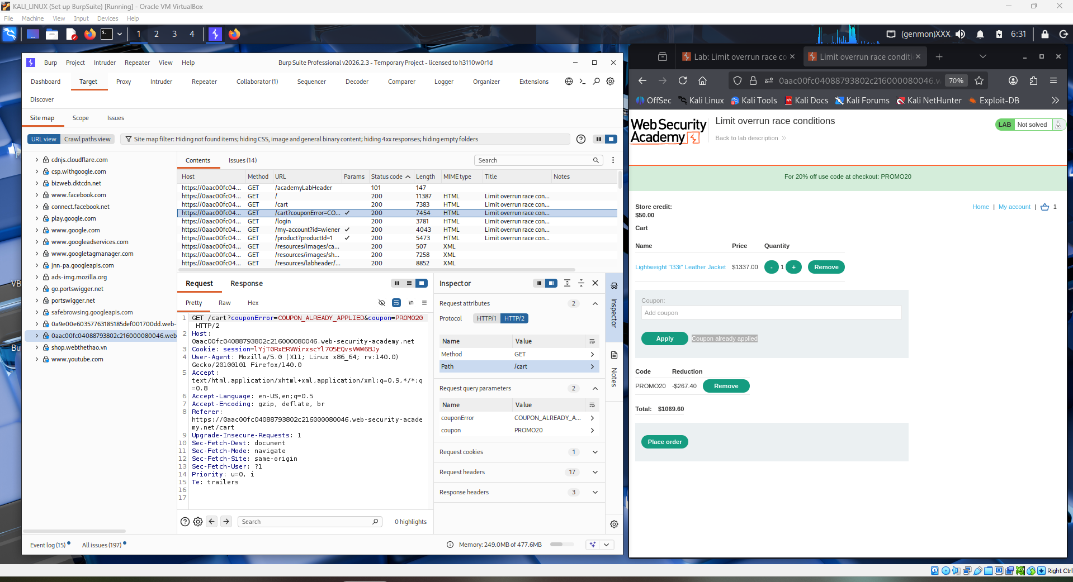
Inside Burp Repeater, the student duplicates the coupon redemption request multiple times by clicking the "+" button to create additional tabs — typically 20 or more copies of the same POST request. Each tab holds an identical request to apply the PROMO20 coupon. This setup prepares the grouped requests needed for the parallel sending technique.
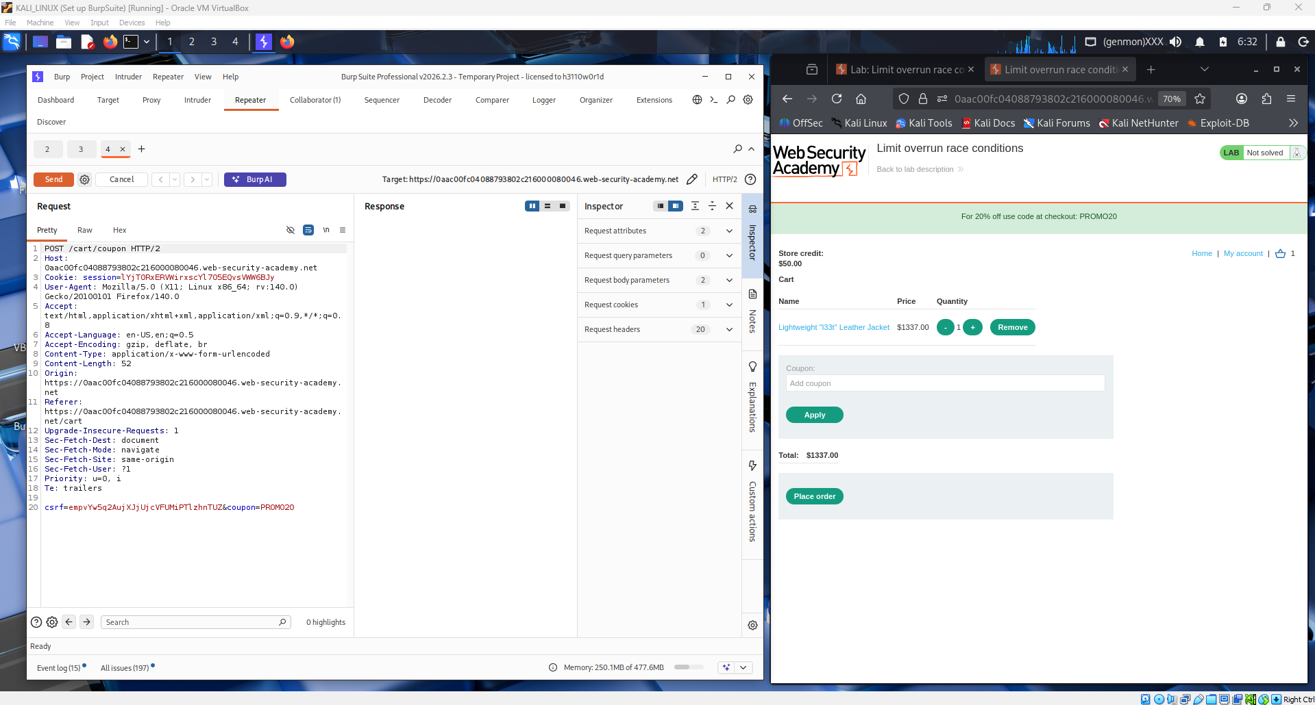
Selects all the duplicate tabs in Repeater, then uses Burp's "Send group in parallel" feature. This sends all coupon redemption requests simultaneously in a single-packet attack, exploiting the narrow race window before the server can update the database to mark the coupon as already used. The goal is to have all requests processed before any of them complete the validation check.
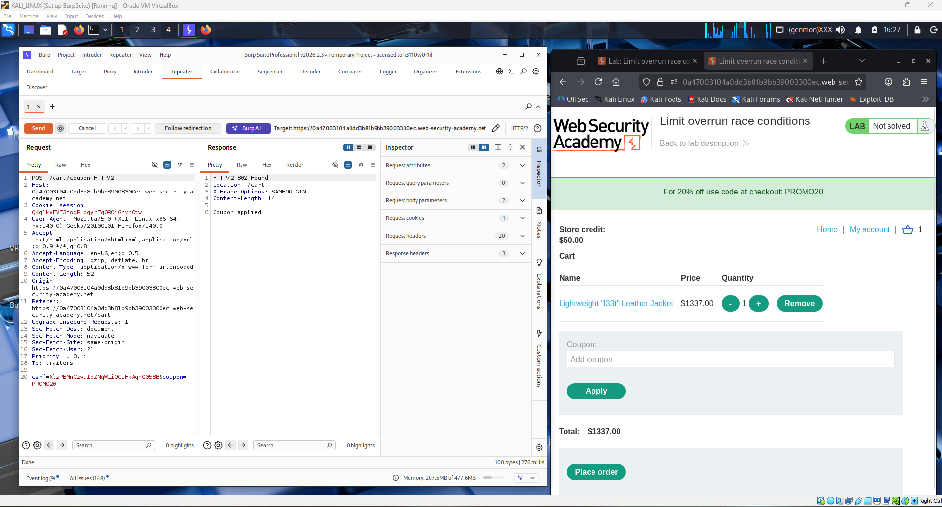
The server responses start coming back. Most return a success response indicating the coupon was accepted, rather than a "coupon already used" error. This confirms the race condition is working — the server processed multiple concurrent requests before the coupon state was properly locked in the database, allowing the same coupon to be applied repeatedly.
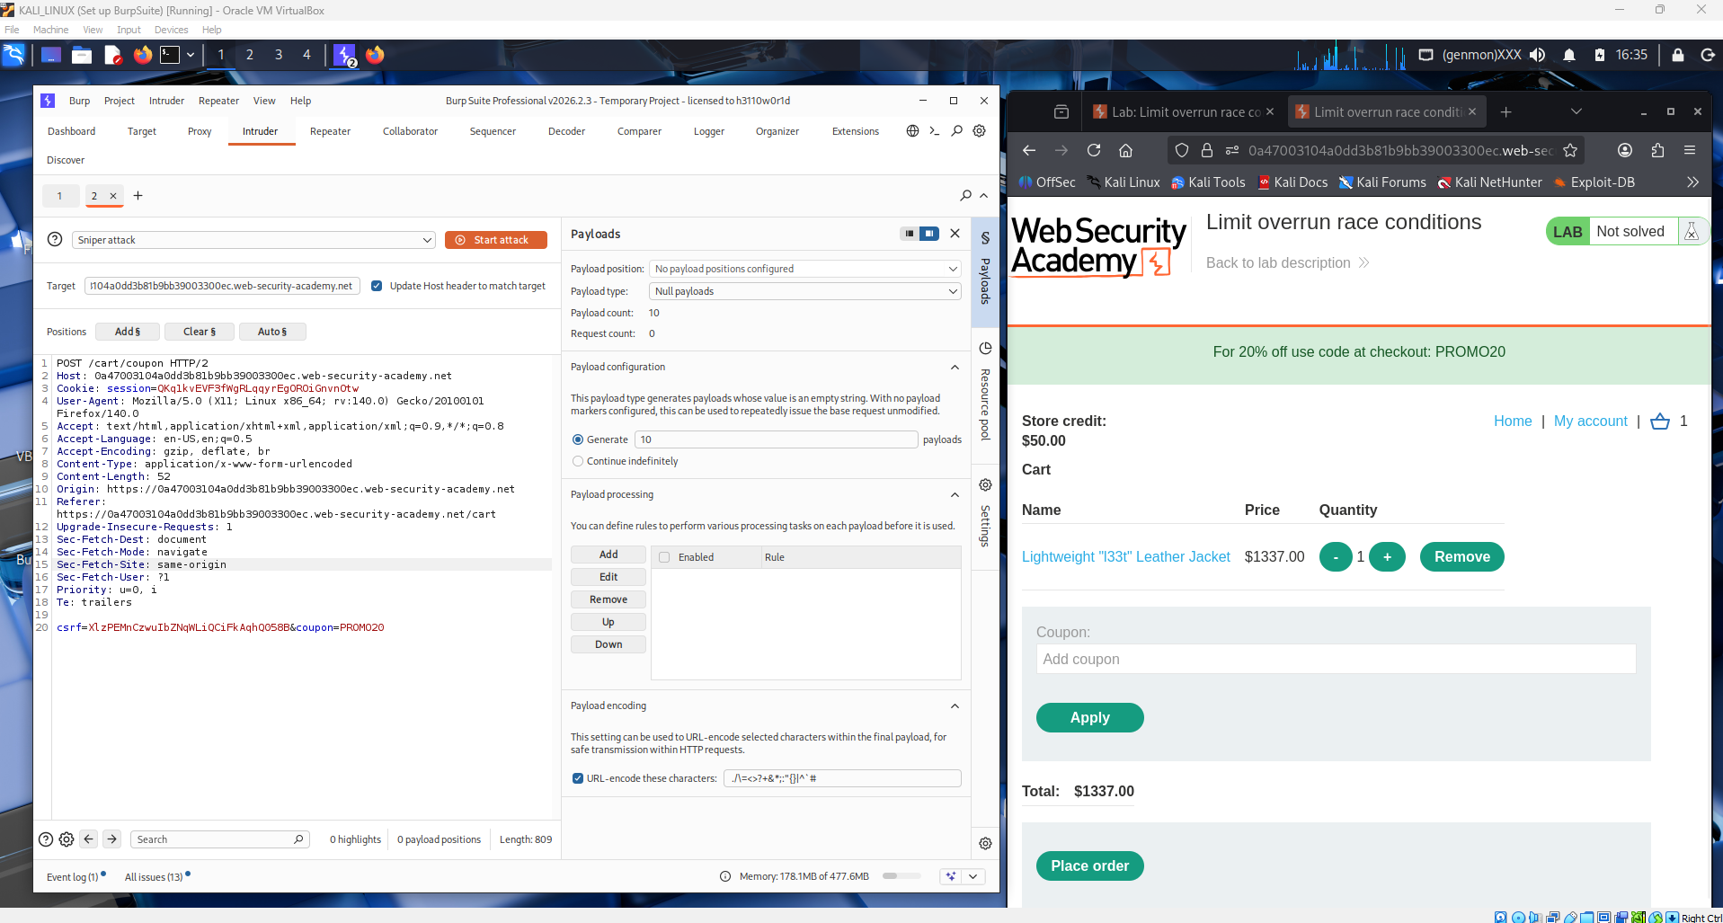
Navigates back to the cart page in the browser to verify the result. The total price has dropped significantly, showing that the PROMO20 coupon was applied multiple times instead of just once. Each successful parallel request stacked another 20% discount on top of the previous one, demonstrating the limit overrun behavior.
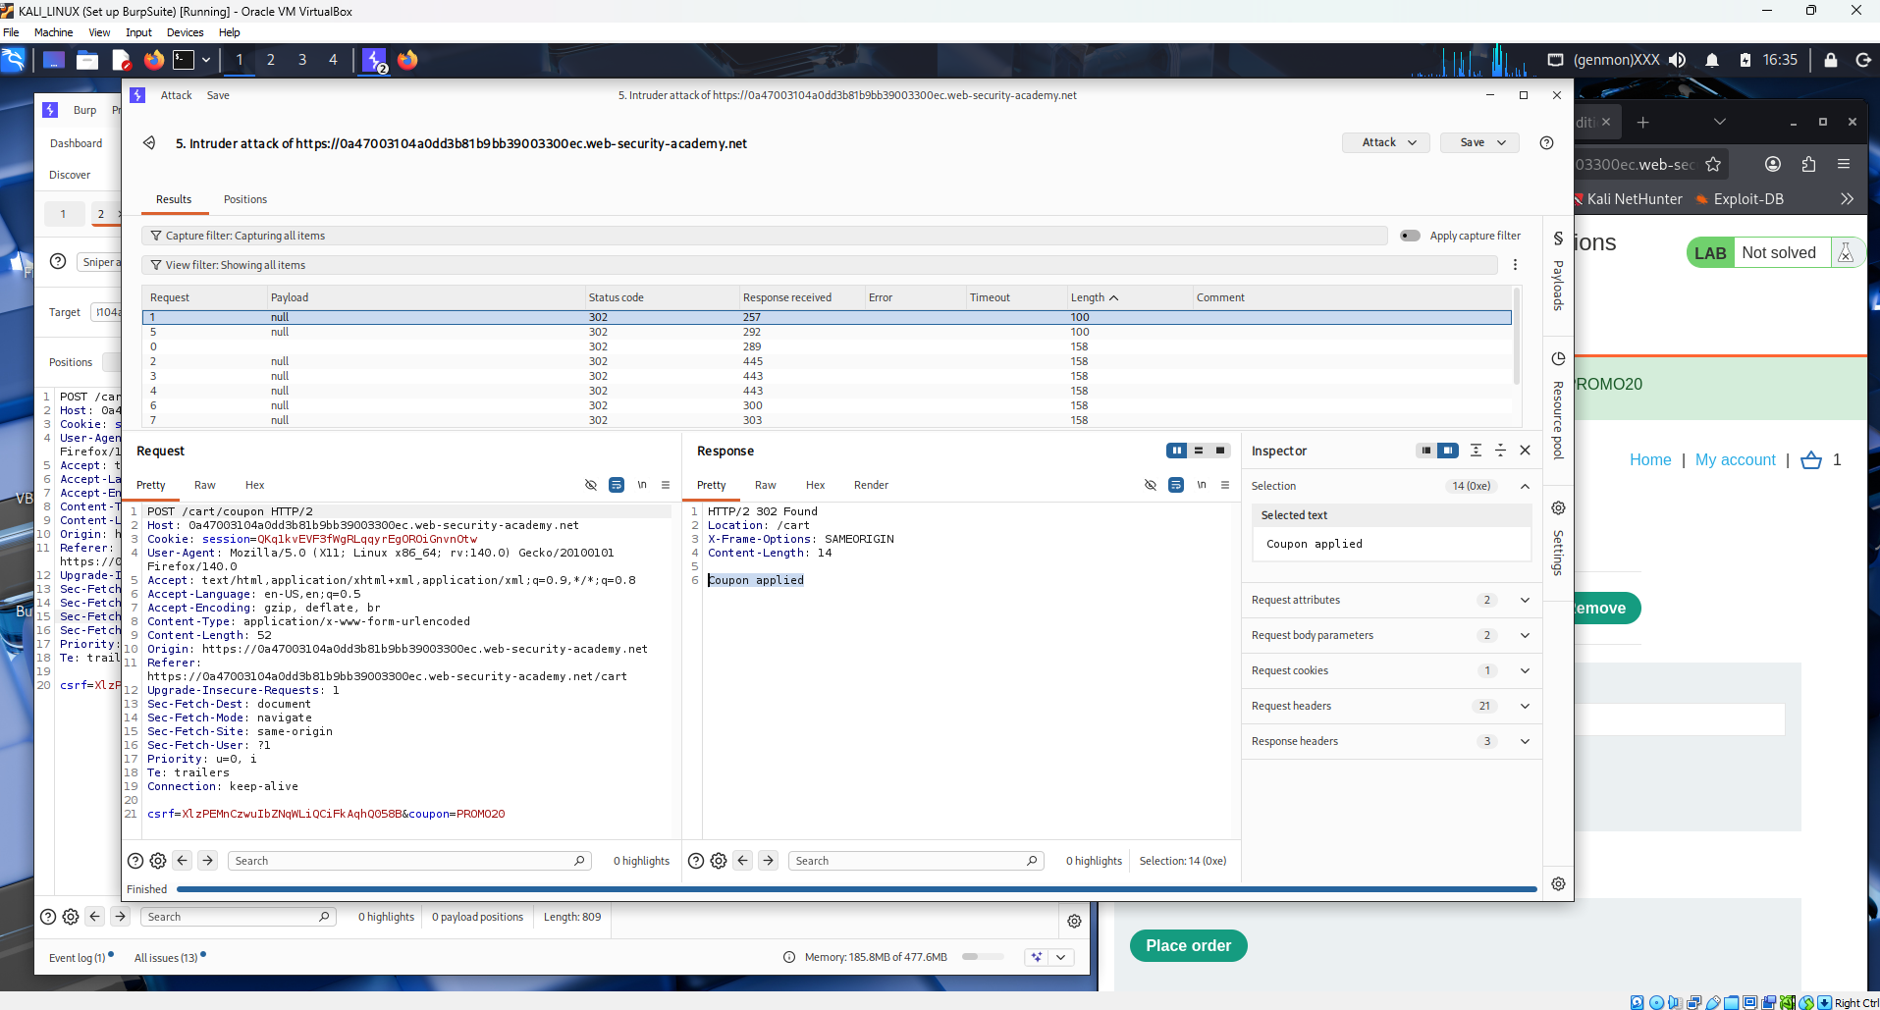
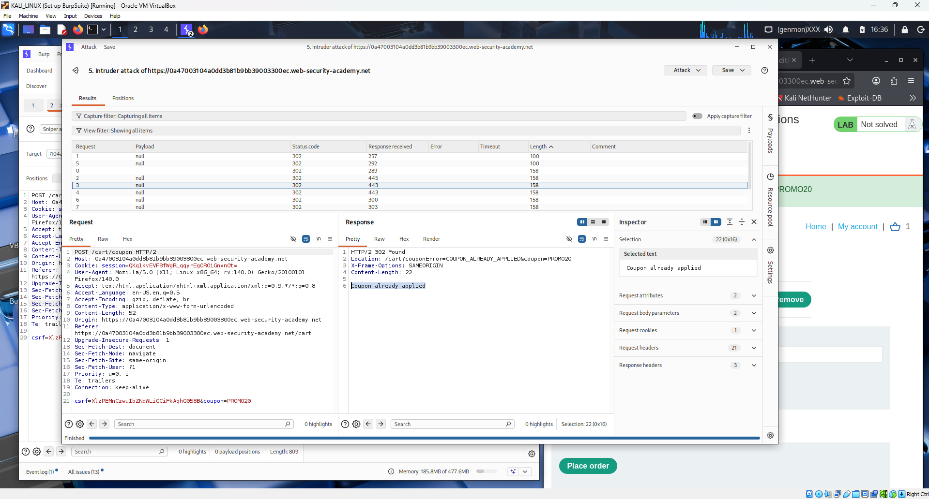

Removes the coupon and resets the cart to prepare for a clean exploitation run. Since the previous attempt may have left the coupon in a partially applied state, the student clears the discounts and starts the process again from scratch to ensure a clean exploit sequence that brings the price below the available store credit.
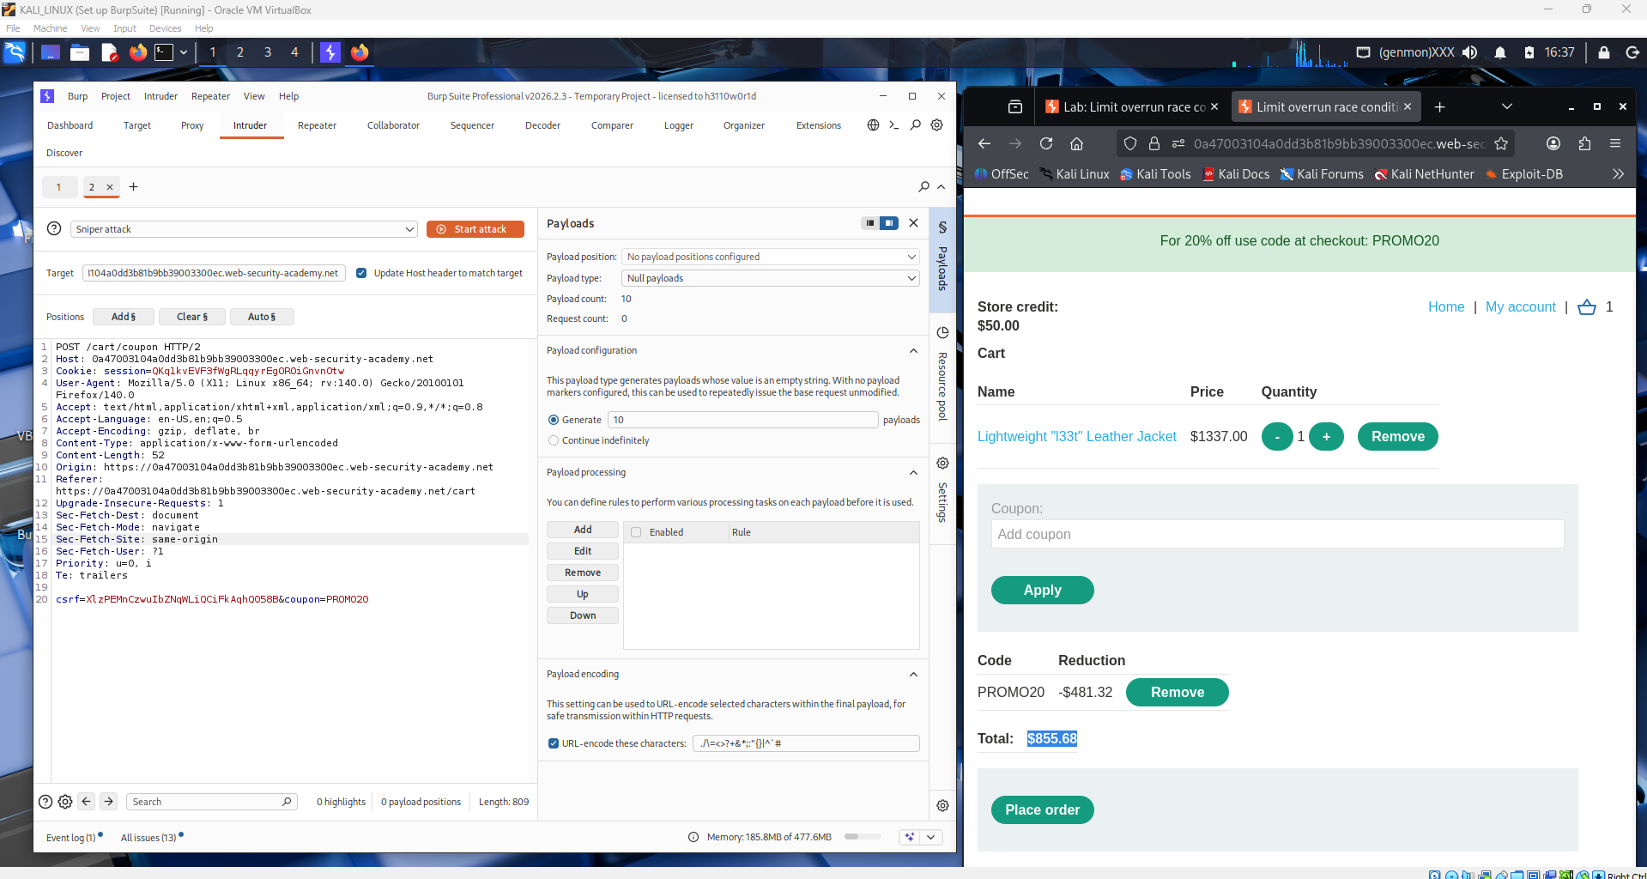

Re-adds the leather jacket to the cart and applies the coupon once through the browser normally to reset the baseline. Burp Suite again captures the POST coupon request, and the student sends it back to Repeater and recreates the group of parallel tabs with the same coupon code for the second exploitation attempt.
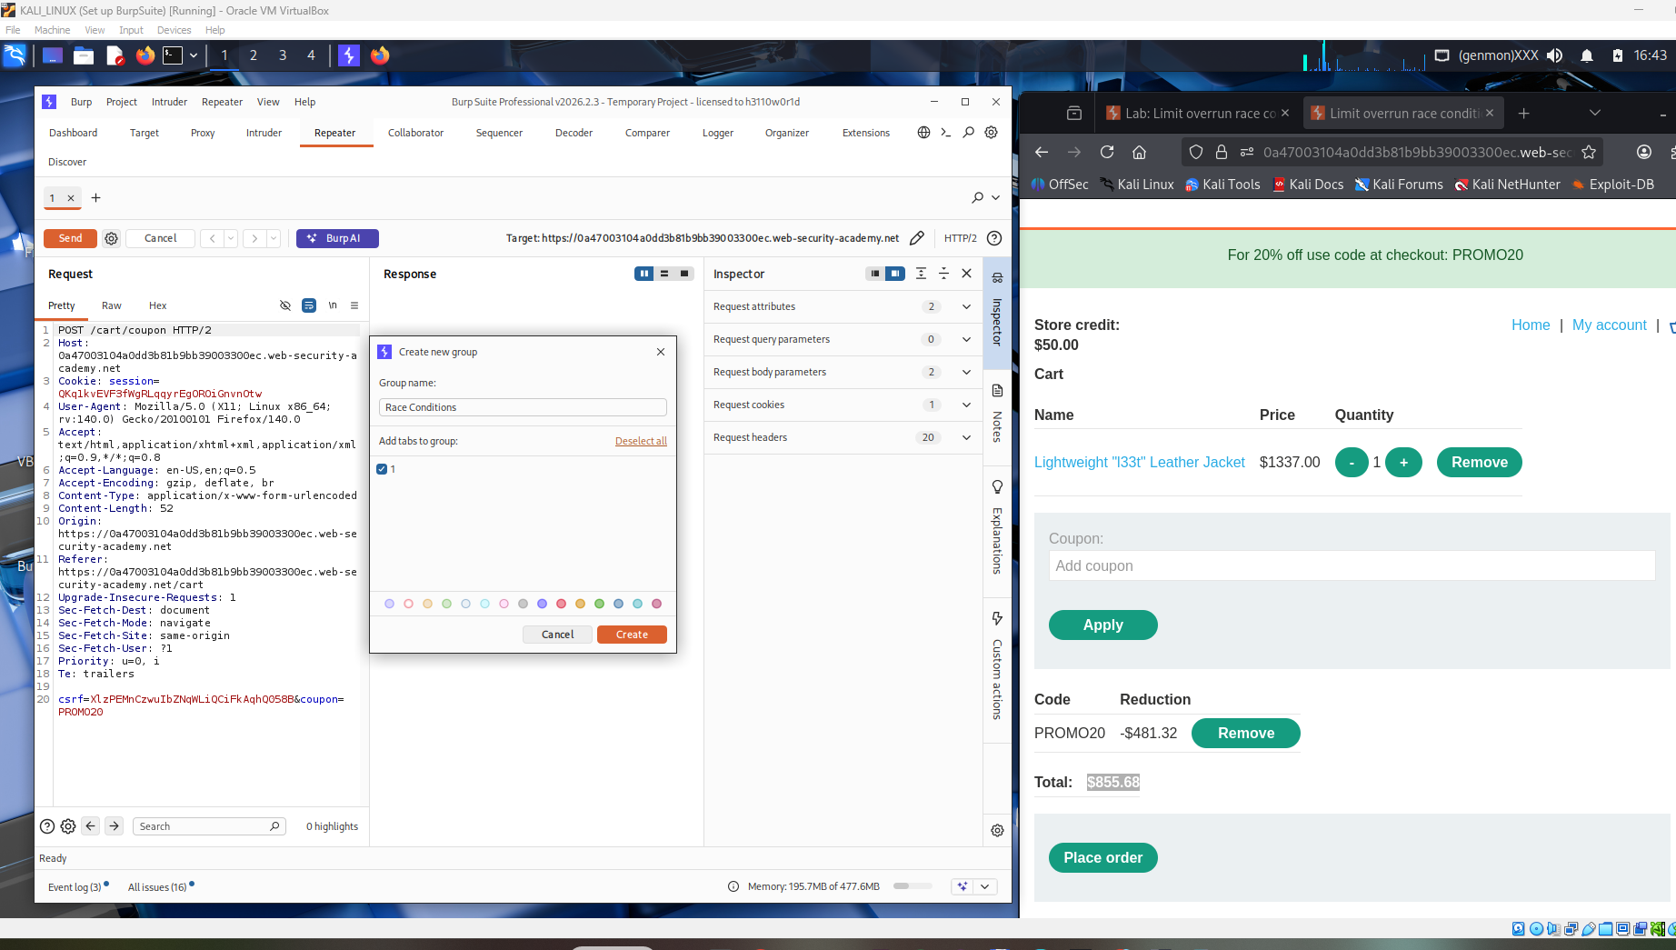
Once again sends the group of parallel coupon requests simultaneously using the single-packet attack in Burp Repeater. The timing is carefully aligned so that all requests arrive at the server in the same TCP packet or within microseconds of each other, maximizing the chance that the server processes them all before any one of them triggers the "already used" check.
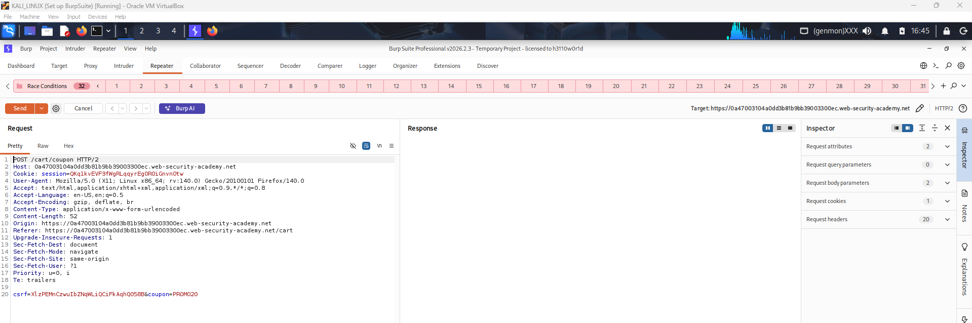

The responses confirm multiple successful coupon applications. The student switches back to the browser and checks the cart total again, which now shows the price has been reduced well below the $100 store credit provided by the lab. The cumulative discount from multiple coupon applications has made the item effectively free or purchasable with the available credit.
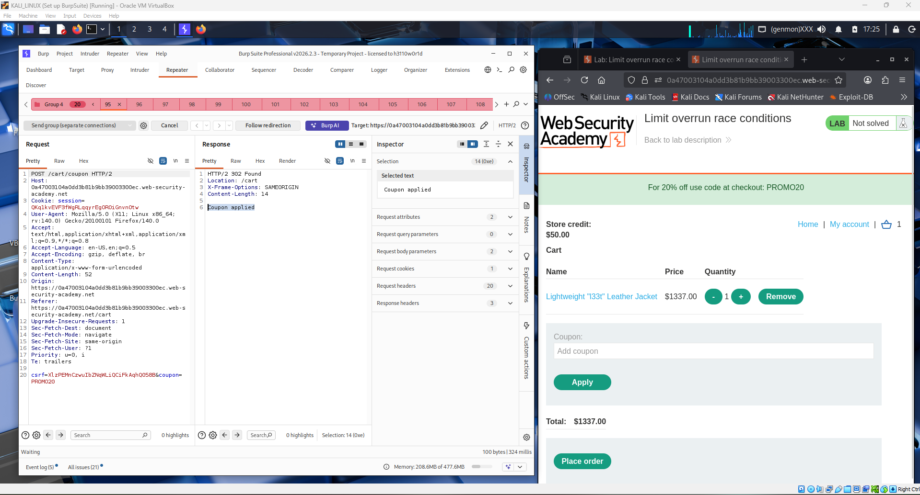
Proceeds through the checkout flow, selecting the store credit as the payment method. Since the cart total is now within the available credit balance thanks to the stacked discounts from the race condition exploit, the checkout system accepts the payment without requiring a real credit card.
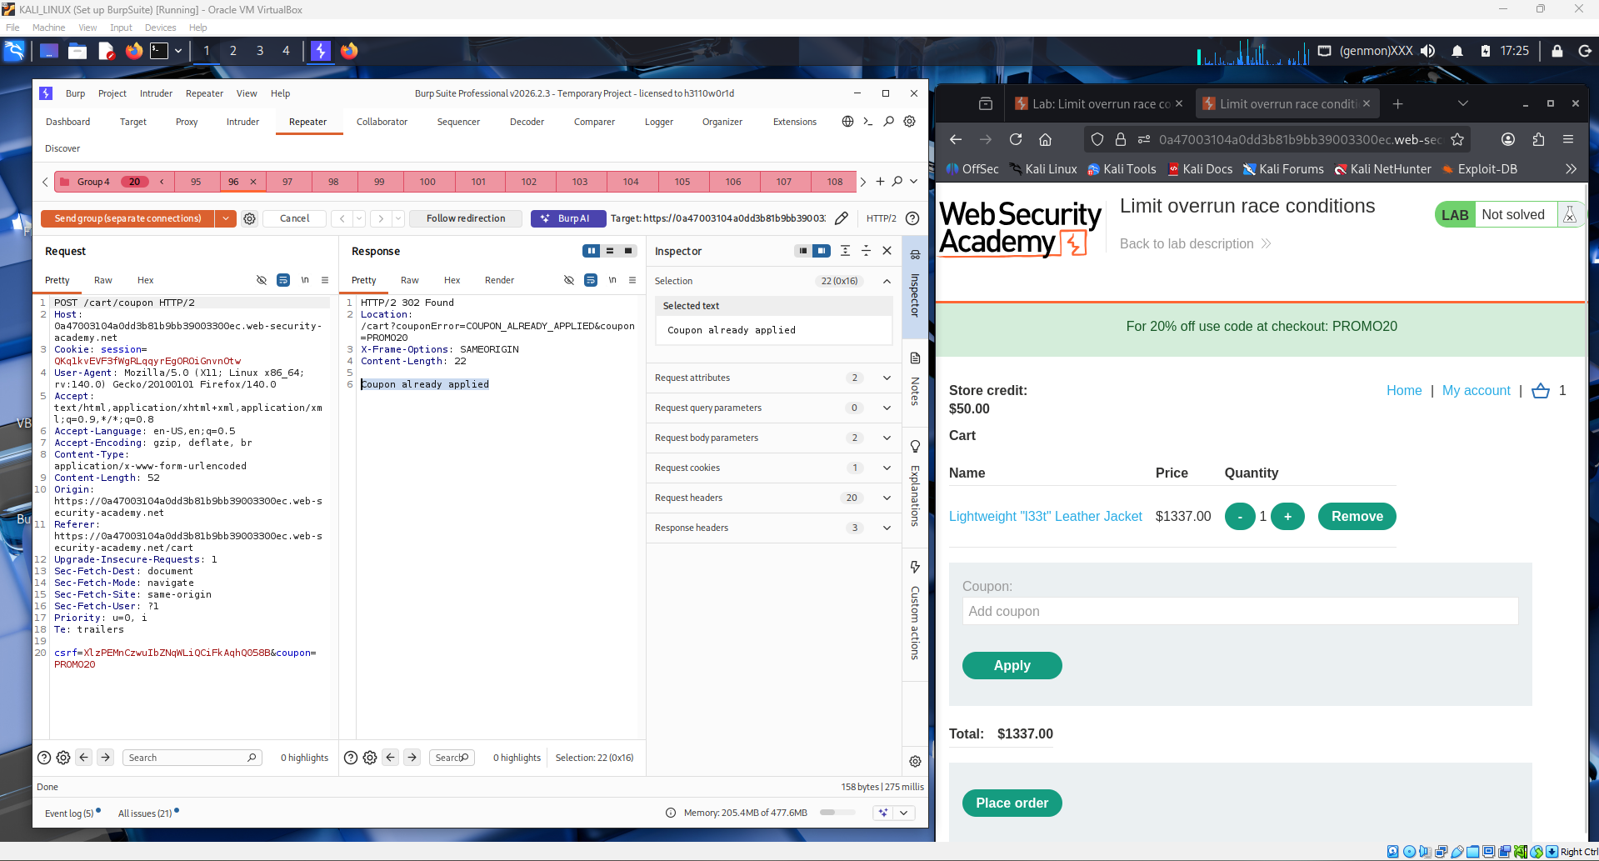
Confirms the order on the checkout confirmation page. The order summary shows the leather jacket with the heavily discounted price, and the student clicks the "Place order" button to finalize the purchase using only store credit.
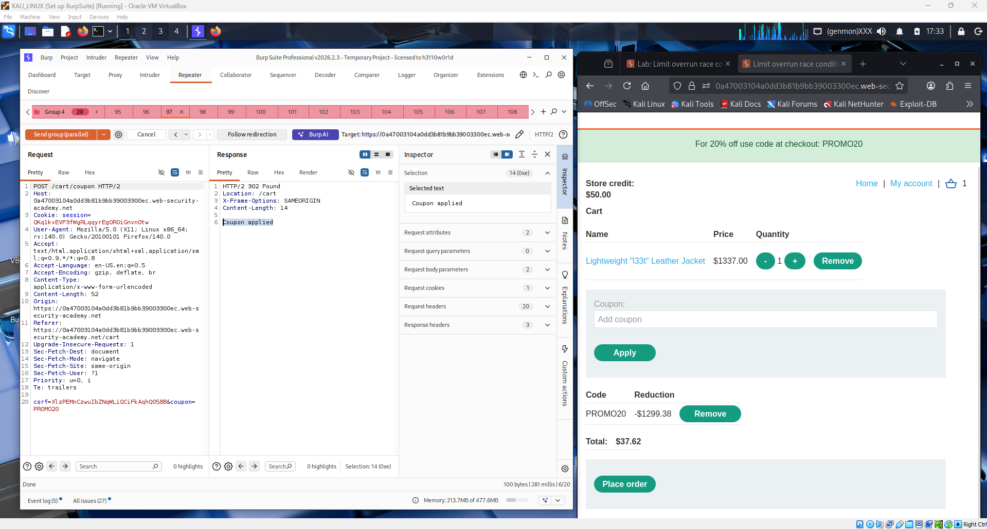

The order is successfully placed. The browser displays an order confirmation page showing the purchase was completed. The student has successfully exploited the race condition to purchase the $1337 leather jacket for a fraction of its original price by abusing the concurrent coupon redemption vulnerability.
The lab banner at the top of the page updates to reflect the solved state. The PortSwigger interface confirms that the lab objective has been met — the student exploited a limit overrun race condition to apply a single-use coupon multiple times and purchase the target item.
The lab is marked as fully "Solved" with the green confirmation banner visible at the top of the browser. This final state confirms that the entire race condition exploitation chain was completed successfully: identifying the vulnerable endpoint, crafting parallel requests using Burp Repeater's single-packet attack, stacking multiple coupon discounts, and completing the checkout below the store credit limit.
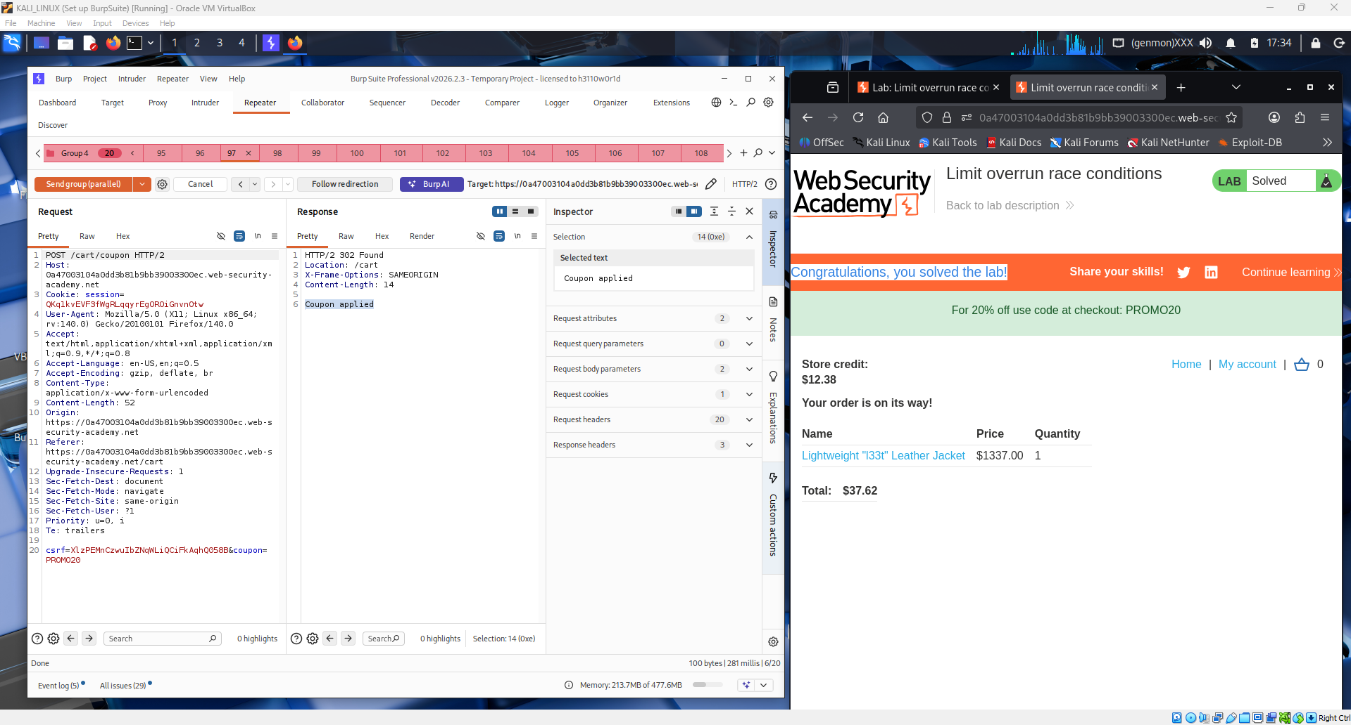

Q1: What are Race Conditions vulnerabilities, and how do they differ from other types of vulnerabilities in web applications?
A race condition vulnerability occurs when the security or correctness of a system depends on the relative timing or ordering of two or more concurrent operations, and an attacker is able to manipulate that timing to reach an unintended state. In a web application context, this typically happens when multiple requests are processed simultaneously and the application reads and writes shared state — such as a database record or a session variable — without proper synchronization. The window of time between when the state is read and when it is updated is called the race window, and an attacker who can send requests that land inside that window can exploit it.
Race conditions differ from most other web vulnerabilities in a fundamental way: they are not caused by flawed logic in any single request, but by the interaction between multiple requests happening at the same time. SQL injection, XSS, or SSRF can all be exploited with a single, carefully crafted request. A race condition requires concurrent execution and is therefore highly timing-dependent, making it harder to detect with standard scanning tools and harder to reproduce consistently. Unlike input validation flaws, the code may look perfectly correct when read in isolation — the bug only emerges under concurrent load. This also makes race conditions more difficult to patch, as the fix requires proper locking mechanisms or atomic database operations rather than simple input sanitization.

Q2: Describe the process of exploiting a Race Conditions vulnerability in a web application or system.
Step 1 — Identify state-dependent operations. The attacker first looks for application features that check a condition and then act on it, where both steps happen without a lock. Classic targets include coupon/promo code redemption, gift card balance checks, limited-quantity item purchases, password reset token consumption, and account balance transfers. Any feature where the application reads a value, makes a decision, and then writes a new value is potentially vulnerable.
Step 2 — Understand the race window. The attacker studies the request-response cycle for the target operation to understand how long the race window lasts. A shorter window requires more precise timing but is still exploitable with modern tools like Burp Suite's single-packet attack, which sends multiple HTTP/2 requests in a single TCP packet to eliminate network jitter.
Step 3 — Craft parallel requests. Using Burp Suite Repeater, the attacker duplicates the vulnerable request many times — typically 20 to 50 copies — and groups them for simultaneous sending. All requests are identical and target the same vulnerable endpoint with the same parameters.
Step 4 — Execute the single-packet attack. The attacker uses the "Send group in parallel" option in Burp Repeater, which leverages HTTP/2 to deliver all requests in one TCP packet. This ensures the server receives and begins processing all requests before any single one has completed, maximizing overlap inside the race window.
Step 5 — Analyze responses and confirm exploitation. The attacker reviews the responses. If multiple requests return a success status that should only be possible once, the race condition is confirmed. The attacker then measures the tangible impact — extra coupon uses, inflated balances, bypassed rate limits — and repeats as needed.
Step 6 — Escalate. In more severe cases, race conditions can be chained to bypass authentication checks, withdraw more funds than available, or create duplicate accounts, leading to significant security breaches or financial damage.

Conclusion
This lab demonstrated a limit overrun race condition in a coupon redemption system. The application checked whether a coupon had been used and then marked it as used in two separate, non-atomic steps, creating a race window where multiple concurrent requests could all pass the check before any of them completed the write. By sending 20 or more identical POST requests simultaneously using Burp Suite's single-packet attack technique, the student was able to apply the same single-use promo code repeatedly, stacking 20% discounts until the price of a $1337 leather jacket dropped below the available store credit. This lab highlights that race conditions are not theoretical edge cases — they are practical, exploitable vulnerabilities that arise from a common and easily overlooked coding pattern. The correct mitigation involves using atomic database operations, pessimistic locking, or idempotency keys to ensure that check-and-act operations can never be interleaved across concurrent requests.

